Web Page Content ProForma

Please submit to kainsworth@worcestershire.gov.uk no later than Friday 1st July.

Project Name: Proof of Concept
These logos need to go on the top of the page.
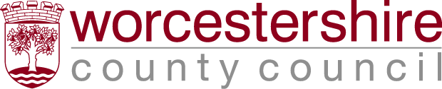

Description of Project (No more than 150 words):
Worcestershire County Council Proof of Concept grant funding programme can support SME’s to investigate, advance, commercialise and protect early stage innovative business ideas, through a partnership with the Central Technology Belt (CTB).
The Proof of Concept fund will provide grants of up to 50% of the total cost of a project (to a maximum contribution of £30,000) for businesses to prove that their innovations have significant economic potential.
Benefits to the companies:
The grant can fund;
- New machinery - Hardware and Equipment
- Market Research and Assessment
- IPR Protection
- Accreditations
- Prototyping
- Marketing/Events/Demonstrations
- Building works

Please note only external expenditure can be funded; internal costs such as staff salaries cannot be funded.
The business would receive support from CTB Business Manager to get draft applications appraisal ready.

Purpose: The grant encourages businesses to bring new products to market and introduce new products to the business, which will result in increased economic benefit and job creation in Worcestershire.

Eligibility
To qualify, your business must:
- Be situated in and trading from Worcestershire, and
- Employ fewer than 250 employees, and
- Have a turnover of less than the equivalent of 50 million Euros per annum or an balance sheet of less than 43 million Euros
- Applicants must demonstrate that they can match fund the remaining 50% of the project
- costs.

Please note some industries such as primary agriculture and retail are not eligible. Other activities excluded are social welfare and education facilities, banking and insurance.
y/Criteria:

Contact Details(email, phone etc):
Jane Holmes Hollie Kirk
Central Technology Belt Worcestershire County Council
Business Manager EU Programme Manager
07505 066434 07957 632 520
jane@centraltechnologybelt.com Hkirk@worcestershire.gov.uk

Deadline Dates:
The call for applications is now open, and will remain open subject to funding.
How is this project funded?
European Regional Development Fund as part of the European Structural and Investment Funds
Growth Programme 2014-2020. The Department for Communities and Local Government (and in
London the intermediate body Greater London Authority) is the Managing Authority for European
Regional Development Fund. Established by the European Union, the European Regional Development Fund helps local areas stimulate their economic development by investing in projects which will support innovation, businesses, create jobs and local community regenerations. For more information visit https://www.gov.uk/european-growth-funding

Case Studies (Please provide no more than 3 case studies):
Attach the case studies to your email.
Xoptix – See attached PDF
Ammba – See attached PDF.
I have three films available please let me know if you would like them.

